I wish to place_________ Flowers in the church. This year Easter flowers will include flowering spring bulbs and Easter Lilies.

By:___________________________________________________________________

_____________________________________________________________________

Each flower is $10.00 Amount enclosed______________
Make checks payable to “First Presbyterian Church” marked “Flowers” and mail to the church office or place in the offering plate with this form. Orders must be in by April 12, 2017.

______________________________________________________________________________
Please print full name. Check one: In Loving Memory of In Honor of

_____________________________________________________________________________
Please print full name. Check one: In Loving Memory of In Honor of

______________________________________________________________________________
Please print full name. Check one: In Loving Memory of In Honor of

Please print full name. Check one: In Loving Memory of In Honor of

_____________________________________________________________________________

___ Please have a Deacon deliver the Lilies or Spring Flowers to a shut-in or member who is ill.
___I will pick up the Lilies after the service.

All proceeds from the Flowers Fund will go to the
work of the Deacons throughout the year.
Mail this form to 120 Pine Street, Paw Paw, MI 49079

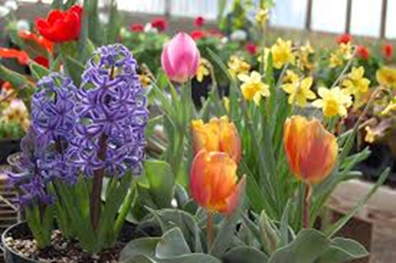
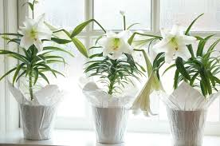

I wish to place_________ Flowers in the church. This year Easter flowers will include flowering spring bulbs and Easter Lilies.

By:___________________________________________________________________

_____________________________________________________________________

Each flower is $10.00 Amount enclosed______________
Make checks payable to “First Presbyterian Church” marked “Flowers” and mail to the church office or place in the offering plate with this form. Orders must be in by April 12, 2017.

______________________________________________________________________________
Please print full name. Check one: In Loving Memory of In Honor of

_____________________________________________________________________________
Please print full name. Check one: In Loving Memory of In Honor of

______________________________________________________________________________
Please print full name. Check one: In Loving Memory of In Honor of

______________________________________________________________________________
Please print full name. Check one: In Loving Memory of In Honor of

___ Please have a Deacon deliver the Lilies or Spring Flowers to a shut-in or member who is ill.
___I will pick up the Lilies after the service.

All proceeds from the Flowers Fund will go to the
work of the Deacons throughout the year.
Mail this form to 120 Pine Street, Paw Paw, MI 49079

